Change of SPG to cope with NTSC without set-up.
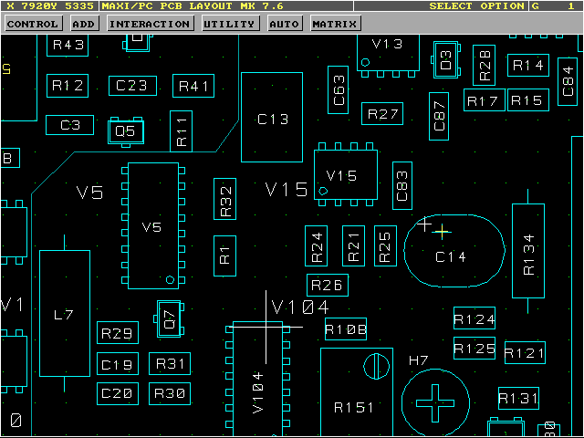

Problem: SMPTE bar , EIA bar and some other signal may prevent correct locking.

Fix:

Mount a 1nF cap in parallel with R1 (refer to drawing below.

Capacitor should be a low temperature coefficient type

31/03-2003/GBG

